Call Flows
I. NRF Interworking
a) NF Registration

Registering NFs in an external NRF
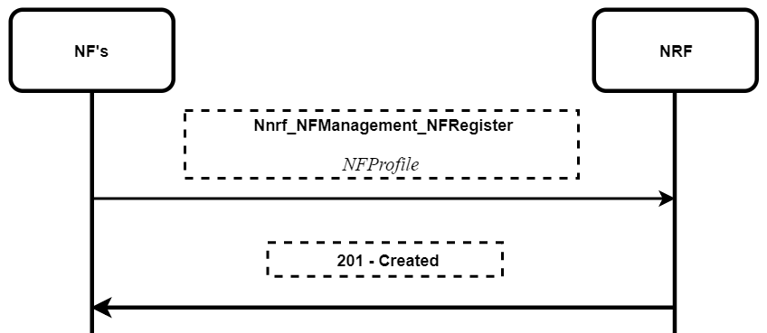
b) NF Discovery

Discovering other NFs to communicate through an external NRF
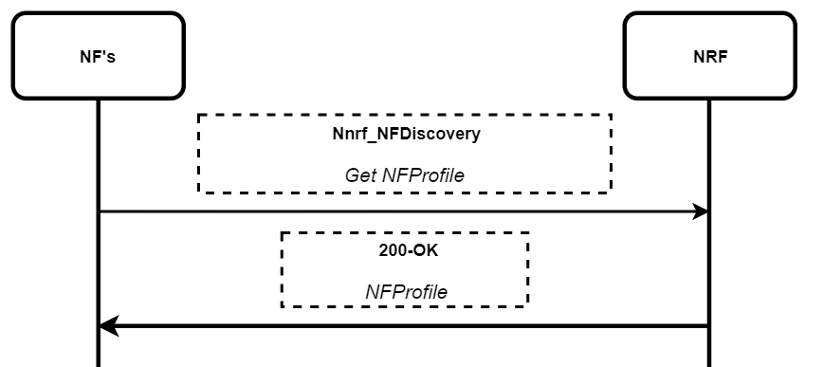

c) NF Profile Update

Updating an NF profile with an external NRF
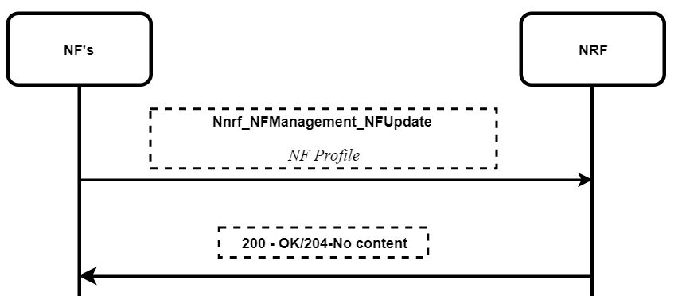

d) NF De-Register

De-registering NFs from an NRF
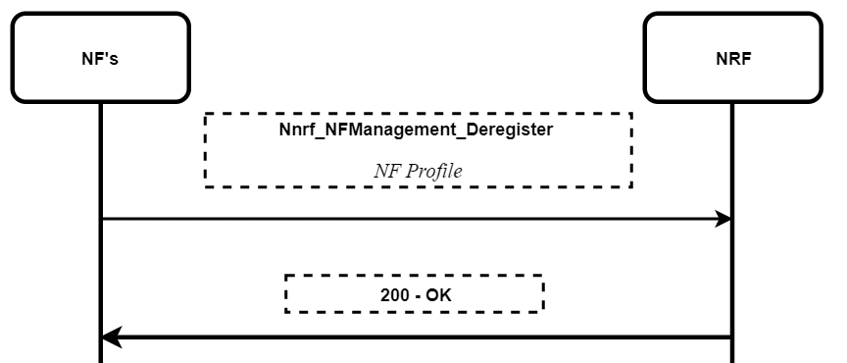

e) NF Subscribe

Subscribing to any remote NF profile changes to which NF needs to communicate
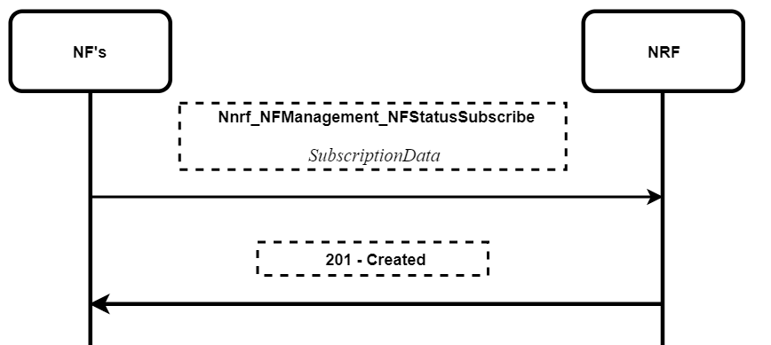

f) NF Unsubscribe

Unsubscribing for target NF profile changes
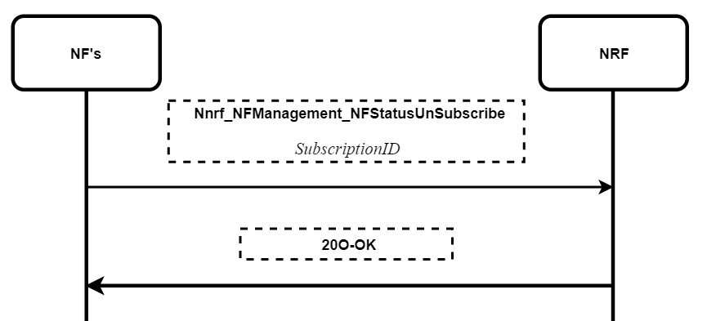

II. 5G Registration
a) 5G-NSA Registration: Subscriber attaching to 5G Radio but with 4G core network

Subscriber attaching to 5G Radio but with 4G core network

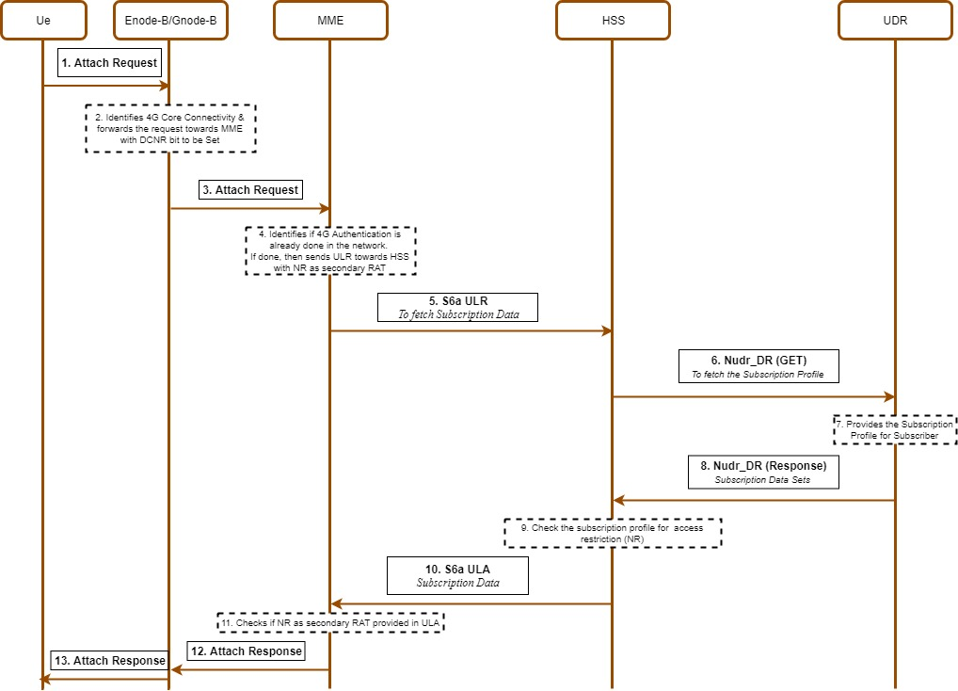

b) 5G-SA Authentication: Authentication with 5G core network (method: 5G-AKA)

Authentication with 5G core network (method: 5G-AKA)
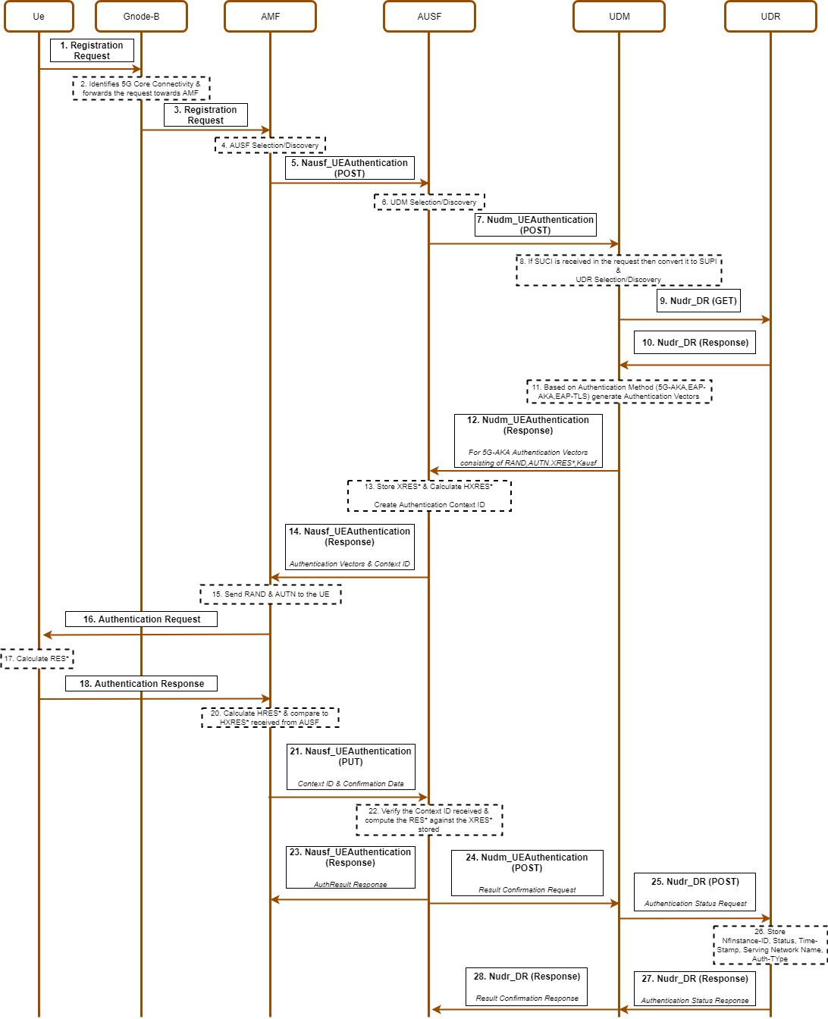
c) 5G-SA Authorization
Authorization within 5G Core network
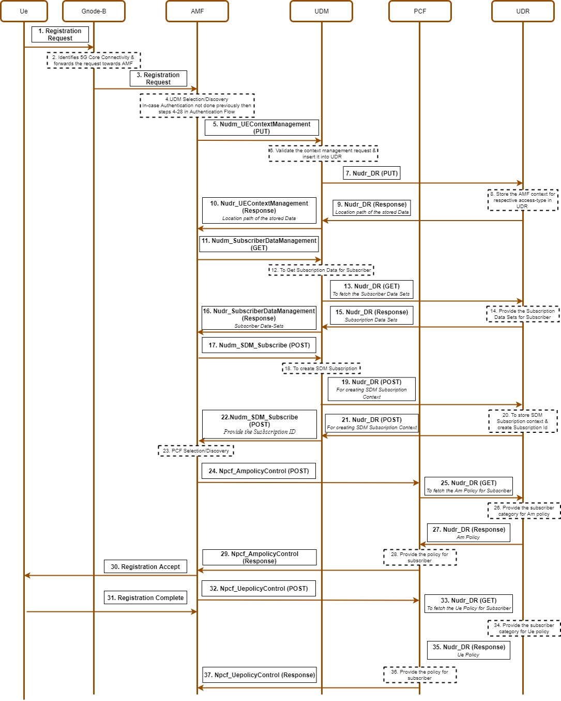
d) Service Request: PDU establishment request with 5G core
PDU establishment request with 5G Core
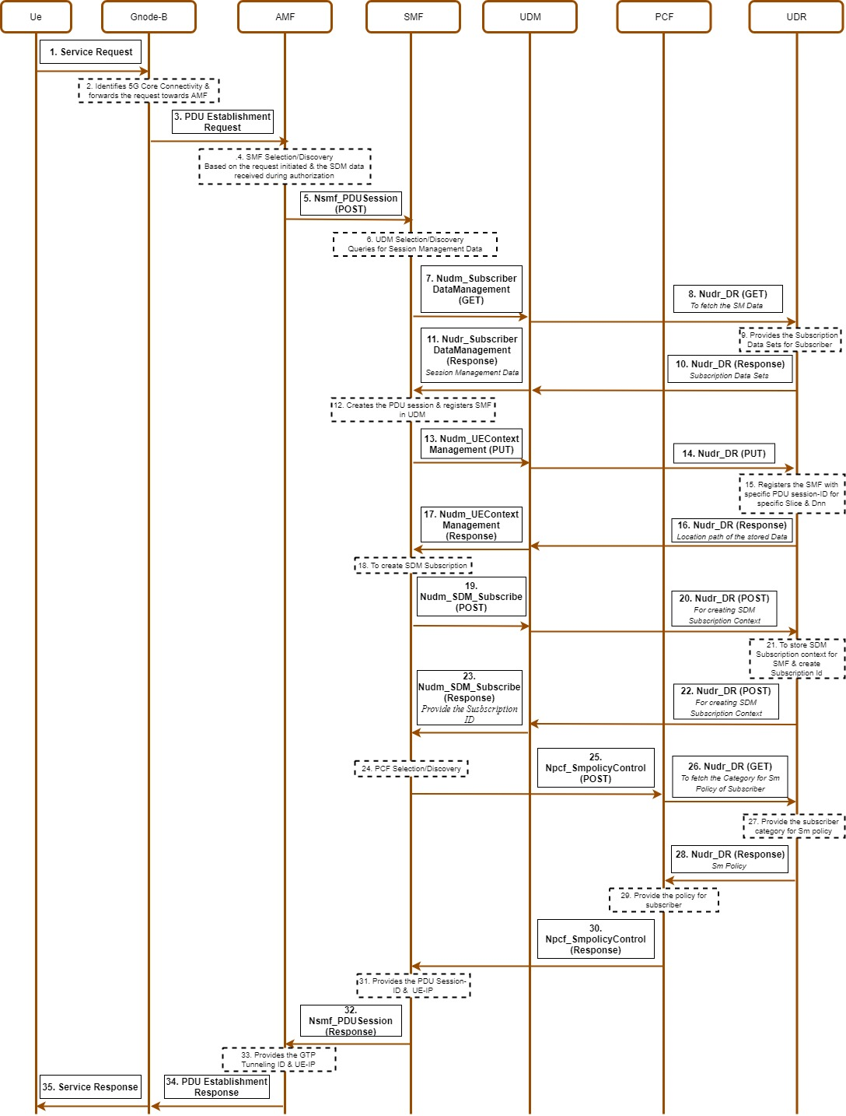

III. 4G Interworking
a) Mobility 4G to 5G: Subscriber moving from 4G network to 5G-SA network

Subscriber moving from 4G network to 5G-SA network

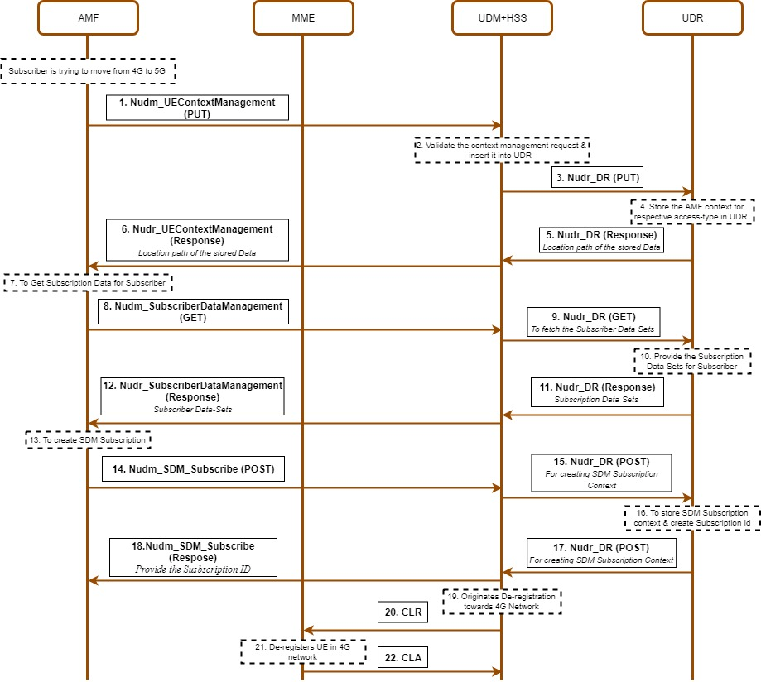

b) Mobility 5G to 4G: Subscriber moving from 5G-SA to 4G network

Subscriber moving from 5G-SA to 4G network
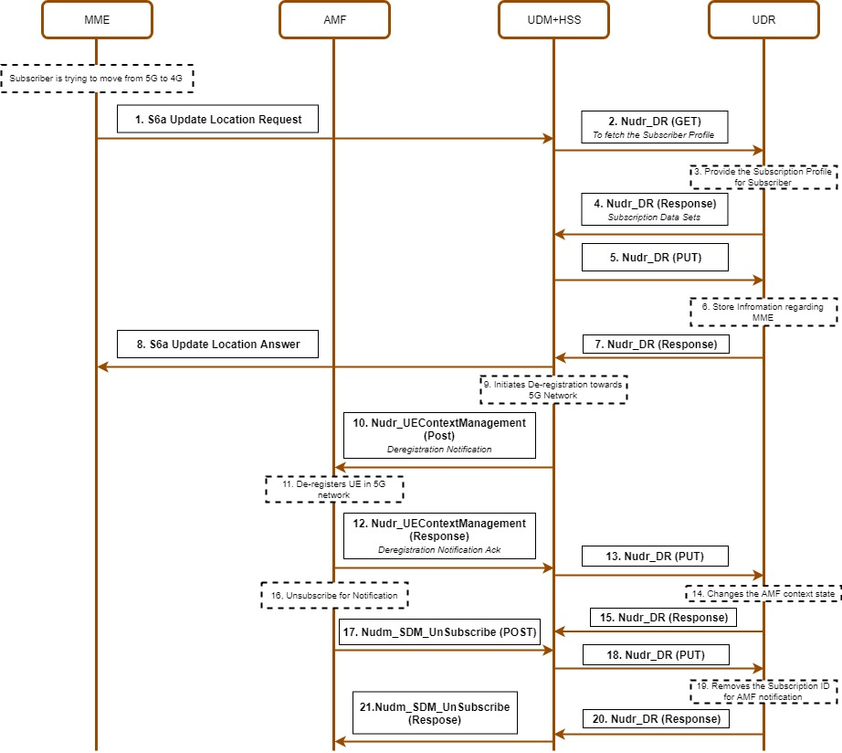

IV. 5G De-Registration

De-registration of Subscriber who is already latched on to 5G network

